Analysis of Montgomery County Traffic Stops

Prepared for the Montgomery County Policing Advisory Commission

Mikhael Gaster
November 8, 2021

Over & Under-Policing – by Race & Ethnicity

Interpretation of Figure 1

Context
Figure 1 shows traffic stop summary statistics by group and ethnicity (“group”). In each group’s sub-chart, each column represents that group’s share of that column’s total across all groups. For example, the “Stops” column in the “ASIAN” sub-chart, which has a value (height) of approximately 5%, shows that stops of Asian drivers accounted for 5% of all traffic stops.
Figure 1 is designed to provide a clear visualization of over and under-policing by group and ethnicity. To determine whether a group is receiving an appropriate amount of attention from the MCPD, we first need to estimate how many drivers there are in each group. Then, for each group, we can compare the share of drivers to the share of enforcement actions (e.g., searches or citations).
Each sub-chart has two blacked-out columns (“MC Pop.” and “Accidents”) which serve as estimates for the number of drivers of each group:
The “MC Pop.” column tells each group’s share of Montgomery County’s population. The main caveat of using this to estimate driver-population is that some groups may be more/less likely to own cars or drive; the greater these differences, the less accurate this estimate is. Nonetheless, it is still the best estimate of driver populations available. The horizontal red line in each sub-chart is set to the same height as “MC Pop.,” to make it easier to compare population to traffic stop outcomes.
The other estimate, “Accidents,” shows each group’s share of all accident-related stops. “Accidents” is a useful estimate for two reasons: first, accident-related tickets are arguably the least discretionary that police can write, so this is close to a random sample (i.e., it is not strongly influenced by any potential bias in the MCPD); second, some groups may drive less safely than others (i.e., have more accidents) – this would lead to drivers of this group being stopped and cited more frequently, even if there is no racial bias in policing. Thus, if “Accidents” is higher than “MC Pop.” for a group, it may indicate that this group drives less safely than average.

Interpretation and Results
Asian Drivers
Asian drivers appear to be under-policed when their share of Montgomery County’s population is compared to their traffic stop outcomes. However, when comparing Asian traffic stop outcomes to the Asian share of accidents, Asian drivers appear to receive a proportionate amount of attention from police. As of 2006, Asian drivers in the U.S. had 1/3rd as many fatal accidents per capita as Hispanic, White, and Black drivers, so it would be reasonable to conclude that they are fairly policed (or, at least, that the data do not provide strong evidence for over or under-policing).
Black Drivers
Black drivers appear to be severely over-policed. Despite making up only 20% of Montgomery County’s population, Black drivers receive 38% of all traffic-related arrests, 47% of searches, and 62% of probable cause searches.
Hispanic Drivers
Hispanic drivers appear to be policed proportional to their share of the population (20%), but they are the only group with a lower share of warnings than citations. In addition, arrests are high (30% of total) and probable cause searches are low (15% of total).
Native American
Native American drivers make up so few stops that it is difficult to draw a conclusion from the data.
Other
“Other” drivers appear over-policed at first glance, but this is largely due to differences in group labels coming from the Census Bureau compared to those from MC data. In addition, it is unclear who officers label as “Other” drivers, and whether this labeling is consistent enough across officers to draw any conclusions across the MCPD as a whole.
White Drivers
White drivers appear extremely under-policed. Compared to their share of Montgomery County’s population (43%), they receive far fewer traffic-related arrests (26%), searches (22%), and probable cause searches (17%).

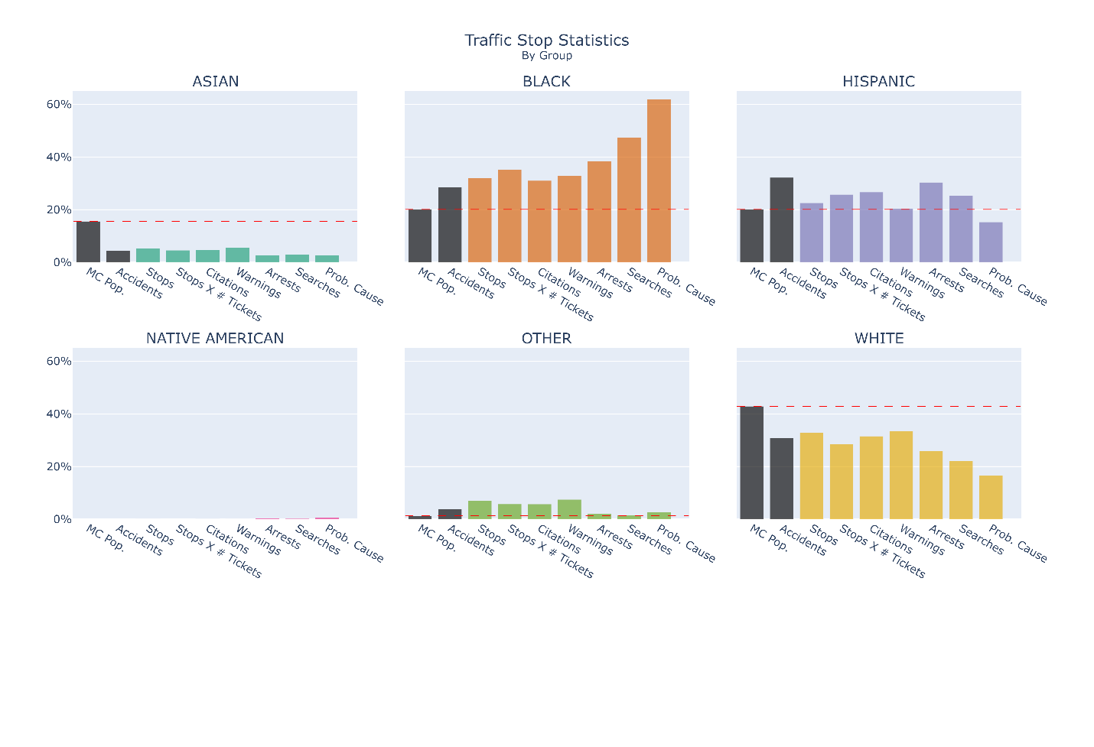
Figure 1

Column Descriptions
MC Pop. – This group’s share of Montgomery County’s population (taken from census data).
Accidents – This group’s share of all traffic writeups due to accidents.
Stops – This group’s share of all traffic stops.
Stops X # Tickets – This group’s share of all traffic writeups. This is different from “Stops” because one stop can have multiple writeups (citations, warnings, and/or repair orders).
Citations – This group’s share of all citations from traffic stops.
Warnings – This group’s share of all warnings from traffic stops.
Arrests – This group’s share of all arrests from traffic stops.
Searches – This group’s share of all searches conducted during traffic stops.
Prob. Cause – This group’s share of all probable cause searches conducted during traffic stops.

2. Police Leniency – by Race & Ethnicity
When drivers are stopped for speeding, the ticket they receive carries a fine and one or more points on their license – both of these punishments are dependent on the speed that they are cited at. For example, when caught speeding on the highway, drivers recorded as driving 1-9 mph over the speed limit receive a fine of $80 and 1 point on their license, whereas drivers recorded as driving 10-19 mph over the speed limit receive a fine of $90 and 2 points on their license.
Police officers often record drivers’ speeds as lower than they actually were, so as to lower a driver’s fine and license points. From the unnatural spike in Figure 2’s distribution, we can infer that most MC stops in the 10-14 mph range were revised down to 9 mph. While this is generally a nice thing for officers to do, it is unfair if this nice act is inconsistently applied to different groups of drivers.
Figure 2 is designed to visualize the differences in police leniency applied to each group, although the interpretation of these numbers is unclear.
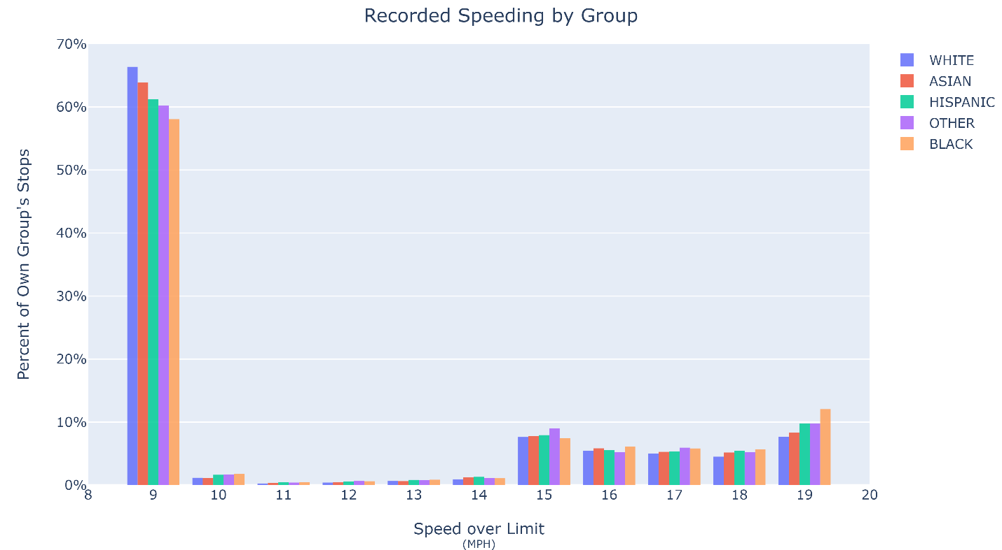
Figure 2
For each group in Figure 2, the height of each bar represents what share of speeding stops (that were recorded between 9-19 mph over the limit) for that group were recorded at a given speed. For example, 66% of White drivers’ stops (that were recorded between 9-19 mph over the limit) were recorded at 9 mph over the limit. For Asian drivers, 64%; for Hispanic, 61%; for Other, 60%; and for Black, 58%.
This could be tentatively interpreted as a ranking of how much preferential treatment the MCPD gives each group, although there are strong caveats that also need to be discussed:
It is likely that the closer a ticket is to a speeding ticket “cutoff” (e.g., 10 mph), the more likely officers are to be lenient. In other words, we can expect officers to be more likely to revise a 10 mph ticket down to 9 mph than to revise a 19 mph ticket down to 9 mph. If this is true, then this ranking may simply reflect the differences in speeding across groups, rather than any police bias. There is some evidence that groups which receive lower rates of revision to 9 mph were simply driving at higher speeds – there is a similar revision at 19 mph (from the 20-29 mph range), and the rates of revision at 19 mph are reversed compared to those at 9 mph, i.e., groups which received relatively higher rates of revision at 9 mph received relatively lower rates of revision at 19 mph.
Officer leniency may be conditional on interpersonal interactions with drivers. If different groups have different attitudes toward the MCPD, they may be more/less friendly to officers, which would lead to systemic differences in leniency.
It is also important to note that even if the above two caveats do not hold, and racial bias is the driving force between differences in speed revision rates for each group, it is still unclear whether a few extremely biased MCPD officers are responsible for these discrepancies, or whether they arise from subtle biases that are widespread throughout the MCPD.
Since it is unclear whether these caveats hold, I do not believe that a clear conclusion (on whether there is bias) can be reached with the data currently published on dataMontgomery. Instead, my conclusion from these findings is that the burden of proof is now on the MCPD to show that they are applying their discretion evenly and fairly.

3. Distribution of Traffic Stops & Automobile Accidents

The MCPD have stated that traffic enforcement is aimed at reducing the incidence of accidents, and hence that the incidence of traffic enforcement is driven by the frequency and location of traffic accidents. To understand the accuracy of this claim, I split MC up into smaller areas, calculated the Stops per Accident in each area, and plotted the distribution of Stops per Accident ratios in Figure 3.
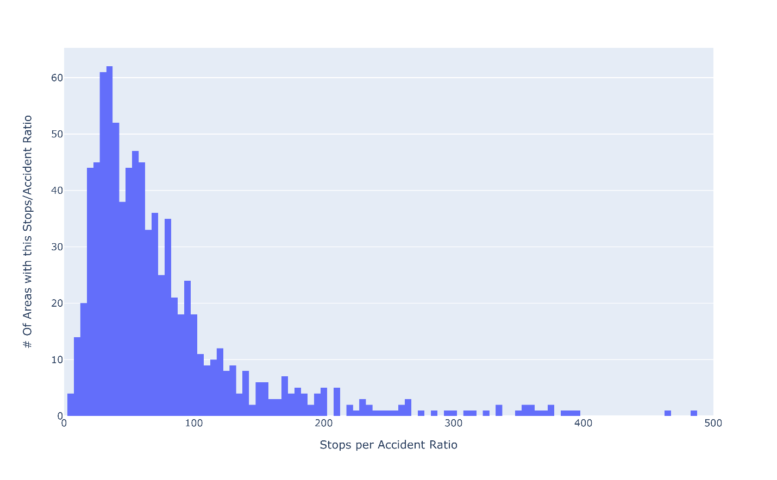
Figure 3
If stop locations are solely determined by accidents, then Figure 3 would appear as a straight vertical line, i.e., all areas of MC would have identical ratios of traffic stops to accidents (since, for example, if one area had more accidents, the MCPD would allocate more officers to that area). On the other hand, if accidents are only minor determinants of where the MCPD patrols and polices, there would be more variance of Stops per Accident ratios across different areas (i.e., we would see a wider and flatter distribution of ratios in Figure 3).
There will always be data quirks, idiosyncrasies unique to areas, and other factors which prevent ratios from being exactly (or even nearly) equal in all areas of MC, so Figure 3 does not tell us conclusively whether accidents are determinants of stops. However, other techniques can tell us how strongly accidents and stops are related.
Figures 3.1, 3.2, and 3.3 plot accidents against stops for all areas of MC (MC has been divided into different-sized areas in each figure). Each contains a statistic which shows how correlated stops and accidents are across different areas of MC (roughly speaking).
Figure 3.1 and 3.2 (and their accompanying statistics) show that when MC is carved into large to medium-sized areas, there is a strong correlation between accidents and stops. Figure 3.3, however, shows that as MC is carved into smaller areas, the correlation between accidents and stops weakens.
Figures 3.1, 3.2, and 3.3 come with two caveats:
These estimates are upper bounds of how closely traffic enforcement is linked to accident rates (i.e., the link between traffic stops and accidents is likely far lower than the estimates provided). This is because even if officers were assigned randomly over MC, they would still drive on the same roads that civilians use, so they would spend more time on busier roads (where most accidents occur). In other words, there is a natural correlation between accidents and stops, whether officers are told where to patrol or not.
Dividing MC into larger areas naturally leads to a stronger correlation between stops and accidents, and dividing MC into smaller areas will naturally lead to a weaker correlation between stops and accidents.
The interpretation of these figures and statistics is therefore dependent on how precise the MCPD claim their traffic assignment is. For example, if they claim to be assigning officers to patrol broad areas that cover many square kilometers, the data do not strongly disagree. On the other hand, the data do strongly disagree if they claim to be assigning officers to patrol areas as small as specific intersections.
One thing that can be concluded with certainty is that there are outlier areas which receive far more stops than their accidents merit (those above the red line in Figures 3.1, 3.2, and 3.3), and there are other outliers which receive far less stops than merited. This does not immediately indict the MCPD of wrongdoing, but the burden of proof has now shifted to the MCPD, and they need to explain how these outliers came to exist.

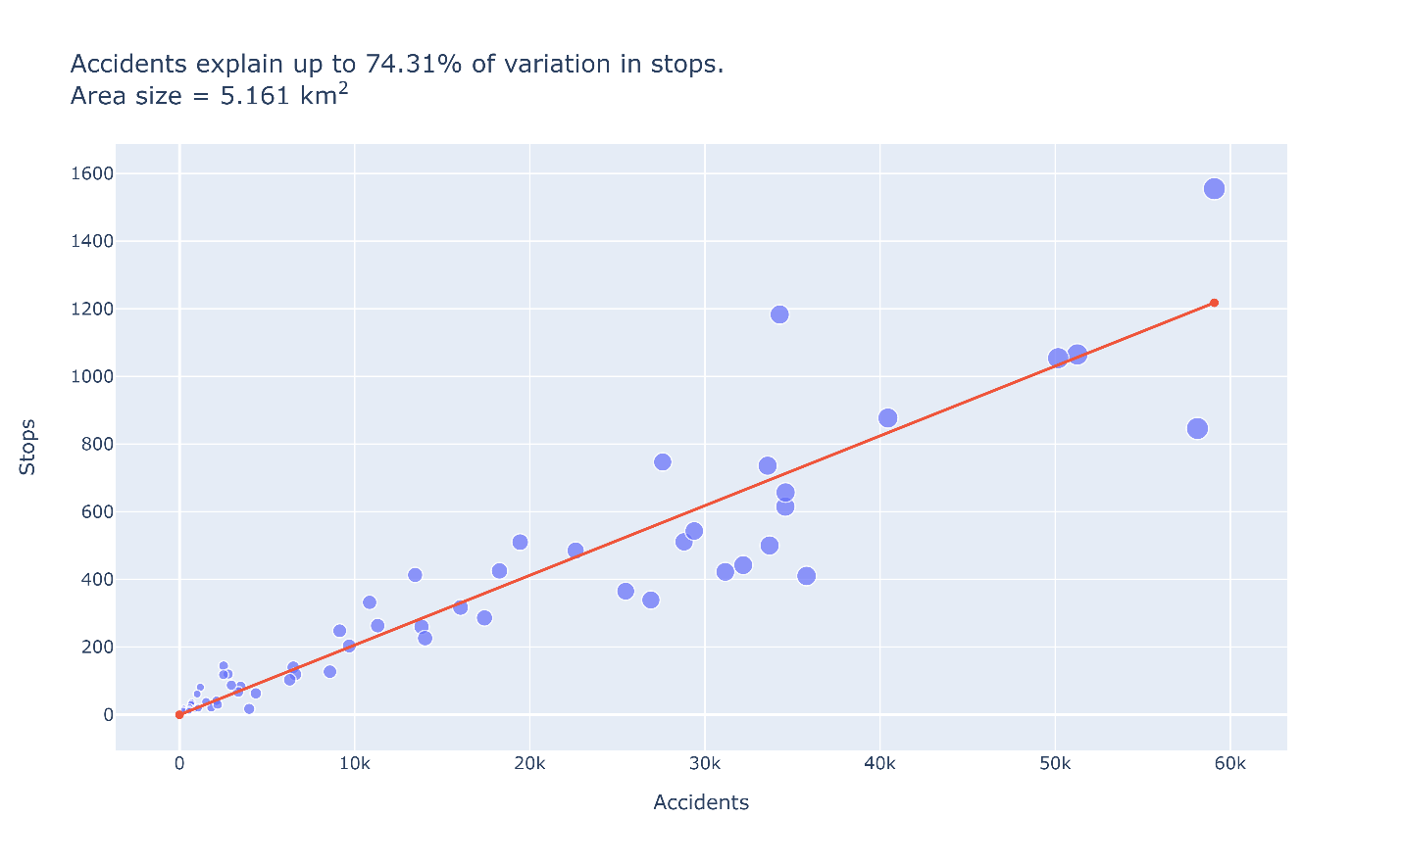
Figure 3.1

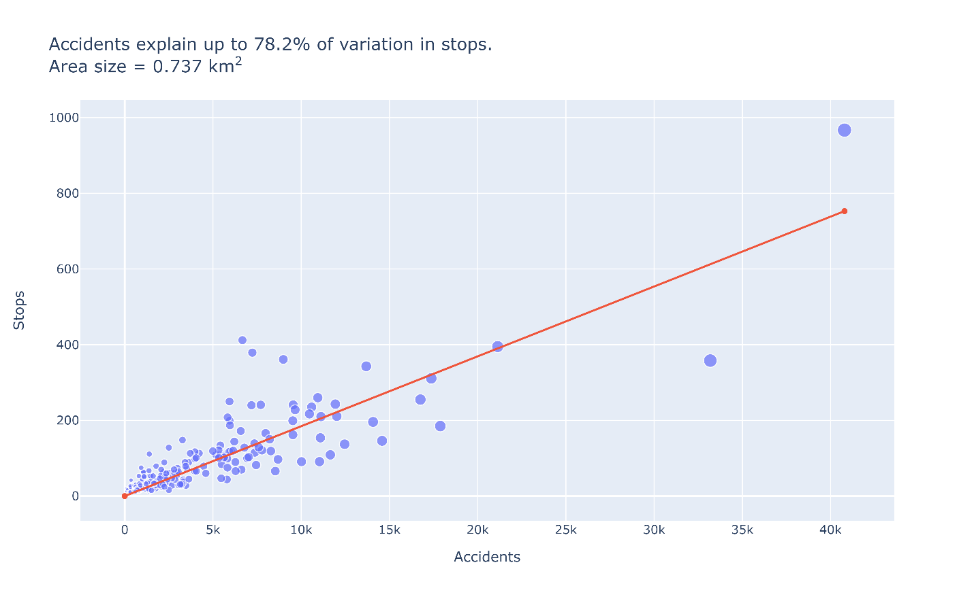
Figure 3.2
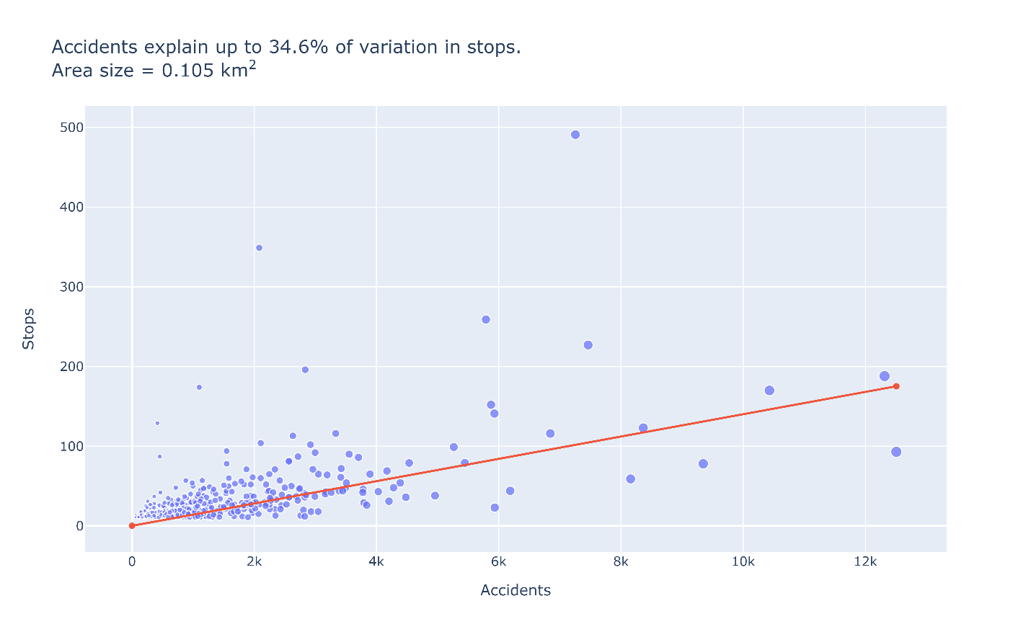
Figure 3.3

Appendix

Traffic stop data was pulled from dataMontgomery, and covers 987,417 traffic stops from 2012-01-01 to 2021-10-05.
Code used for the analysis can be found in this public repository.

Fatality and alcohol-related tickets are also non-discretionary, but they each have caveats that make them less useful as population estimates than accident-related tickets. Fatality-related tickets are too rare to be reliable and precise; alcohol-related are too specific and too sensitive to confounding variables to fairly estimate an entire group (e.g., if one group has a higher proportion of young drivers, they will also have a higher proportion of alcohol-related tickets, so their population estimate would be too high).
While the purpose of this report is not to label any groups as “better” or “worse” drivers on average, it is also unfair to the MCPD to assume that all groups drive identically, so this should be taken into consideration.
Asian drivers appear under-policed because their share of traffic stop outcomes (e.g., stops, arrests, etc.) is much smaller than their share of MC’s population.
https://crashstats.nhtsa.dot.gov/Api/Public/ViewPublication/810995 (page 2). This statistic comes with the caveat that “Asian” is a wide umbrella, and national statistics may not be pertinent to Montgomery County.
Probable cause searches are defined as searches conducted “when evidence of the crime is present in the place to be searched” (Cornell Legal Encyclopedia). Probable Cause searches are especially important in investigations of racial bias in policing because they are discretionary, and depend on the officer’s assessment of the driver.
https://www.courts.state.md.us/sites/default/files/court-forms/district/forms/criminal/dccr090public.pdf/dccr090public.pdf (page 49)
Montgomery County is not unique in this – see: Goncalves and Mello (2021).
There were only 90 speeding stops for Native American drivers, so they are omitted from this figure.
And the data do provide some evidence in support of this hypothesis. All speeds in the 10-14 mph range have artificially lowered speeding rates when compared to speeds in the 15-19 mph range, which implies that officers are more likely to revise tickets in the 10-14 range than they are to revise tickets in the 15-19 range.
Officer-level data will be required to answer this question . These data do not need to be made public, but at the very least they should be reviewed internally if the MCPD wishes to hold biased officers accountable.
Specifically, Figure 3 plots data from splitting MC into hexagons with areas of approximately 0.1 Km², i.e., widths of approximately 0.4 km.
One might think that if accidents do not determine stops at all, we would observe a flat, uniform distribution of Stops per Accident ratios across areas of Montgomery County, however, this would not be the case, because officers naturally drive on the same roads that civilians do, and will therefore be inherently more likely to drive in places that see more accidents.
Specifically, the estimates of how strongly variation in accidents explain variation in stops (displayed in Figures 3.1, 3.2, and 3.3) are found by taking the R² from a weighted least squares regression of Stops on Accidents (weighted by Stops). Note: These regressions only include areas with over 50 stops and over 10 accidents.

